Apache Tomcat and Jenkins Pipeline for MavenAnsibleWebApp1 along with Ansible
Step 1: create a Web app by typing the command mvn archetype:generate –DgroupId=com.example –DartifactId=MavenAnsibleWebApp1 –DarchetypeArtifactId=maven-archetype-webapp –DinteractiveMode=false
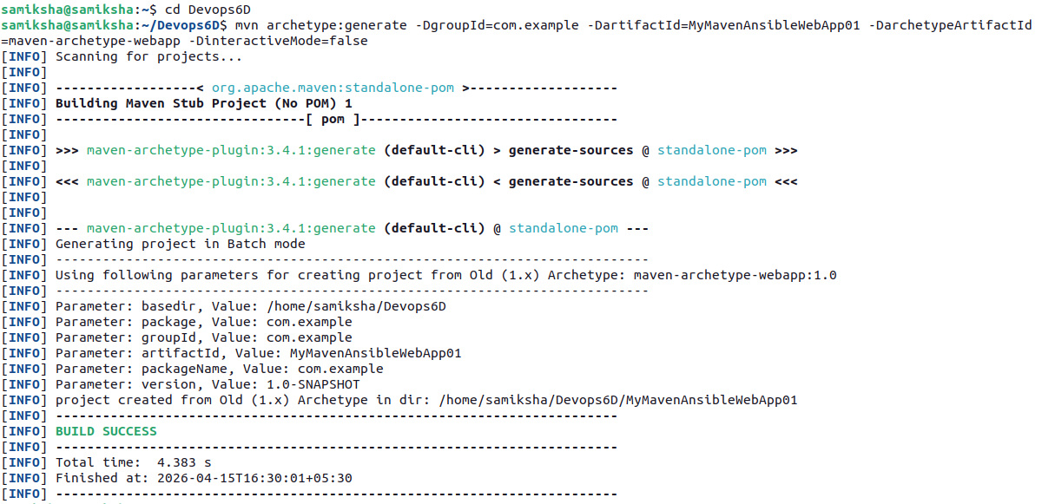
Step 2 : enter the MavenAnsibleWebApp1 , open the pom.xml file and paste the code
<project xmlns="http://maven.apache.org/POM/4.0.0" xmlns:xsi="http://www.w3.org/2001/XMLSchema-instance" xsi:schemaLocation="http://maven.apache.org/POM/4.0.0 http://maven.apache.org/maven-v4_0_0.xsd">
<modelVersion>4.0.0</modelVersion>
<groupId>com.example</groupId>
<artifactId>MavenAnsibleWebApp1</artifactId>
<packaging>war</packaging>
<version>1.0-SNAPSHOT</version>
<name>MavenAnsibleWebApp1</name>
<url>http://maven.apache.org</url>
<dependencies>
<dependency>
<groupId>junit</groupId>
<artifactId>junit</artifactId>
<version>3.8.1</version>
<scope>test</scope>
</dependency>
<!-- Servlet API for Java EE -->
<dependency>
<groupId>javax.servlet</groupId>
<artifactId>javax.servlet-api</artifactId>
<version>4.0.1</version>
<scope>provided</scope>
</dependency>
</dependencies>
<build>
<plugins>
<plugin>
<groupId>org.apache.maven.plugins</groupId>
<artifactId>maven-war-plugin</artifactId>
<version>3.4.0</version>
<!-- Update to latest stable version -->
</plugin>
</plugins>
<finalName>MavenAnsibleWebApp1</finalName>
<!-- create a web page with the name MavenAnsibleWebApp, if we want some other name we can chage it -->
</build>
</project>
Step 3: create Jenkinsfile by typing the command gedit Jenkinsfile and paste the code
pipeline {
agent any // Use any available agent
environment {
LANG = 'en_US.UTF-8'
LC_ALL = 'en_US.UTF-8'
} // this has to be added only if you get an error saying UTF required is 8 but showing in ISO00009 tools {
maven 'Maven' // Ensure this matches the name configured in Jenkins
}
stages {
stage('Checkout') {
steps {
git branch: 'master', url: 'https://github.com/ShruthiBGowda/MavenAnsibleWebApp1-CICD.git'
}}
stage('Build') {
steps {
sh 'mvn clean package' // Run Maven build
}}
stage('Archive') {
steps {
archiveArtifacts artifacts: 'target/*.war', fingerprint:true
}}
stage('Deploy') {
steps {
sh 'mvn clean package'
sh 'ansible-playbook ansible/playbook.yml -i ansible/hosts.ini'
}}}
Step 4: create a new directory by typing the command mkdir ansible . Inside ansible create the hosts.ini file and playbook.yml file.
Paste the following code in hosts.ini
[web]
localhost ansible_connection=local ansible_python_interpreter=/usr/bin/python3
and paste this code in playbook.yml
- name: Deploy to Tomcat
hosts: web
become: yes
tasks:
- name: Copy WAR file to Tomcat
copy:
src: "/var/snap/jenkins/5013/workspace/MavenAnsibleWebApp1-CICD/target/MavenAnsibleWebApp1.war"
dest: "/opt/tomcat/webapps/MavenAnsibleWebApp1.war"
remote_src: no
- name: Stop Tomcat
shell: /opt/tomcat/bin/shutdown.sh
ignore_errors: yes
- name: Start Tomcat
shell: /opt/tomcat/bin/startup.sh
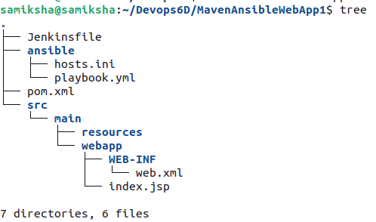
Commit everything and push it to GitHub
Step 5:Go to Jenkins Dashboard click on new item and give the name MavenAnsibleWebApp1-CICD and select pipeline. In the configure select pipeline with scm paste the GitHub url and select git credentials apply and save .
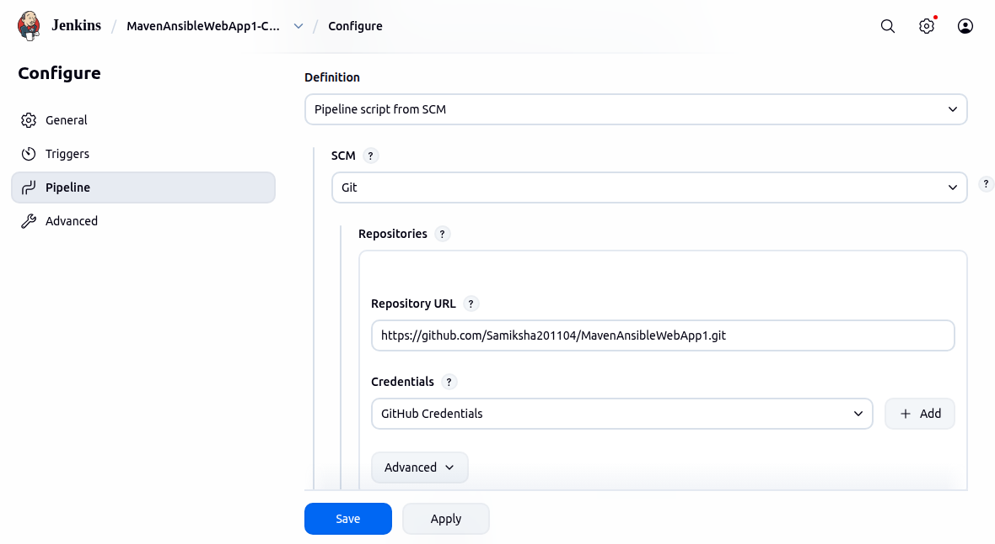
Step 6:Go back to dashboard and build MavenAnsibleWebApp1-CICD
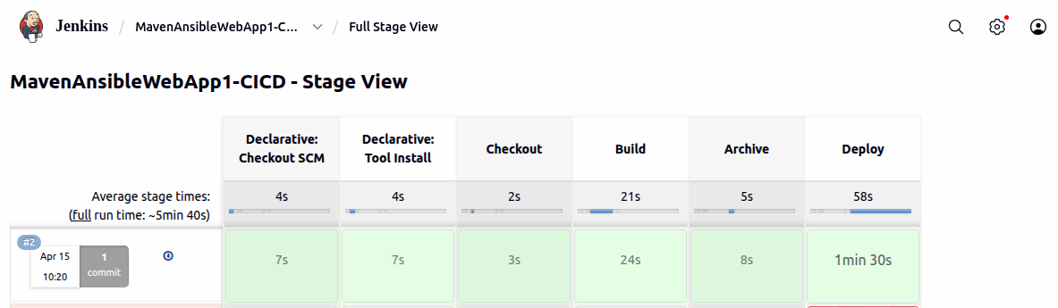
Step 7:Start Tomcat by typing the command sh startup.sh
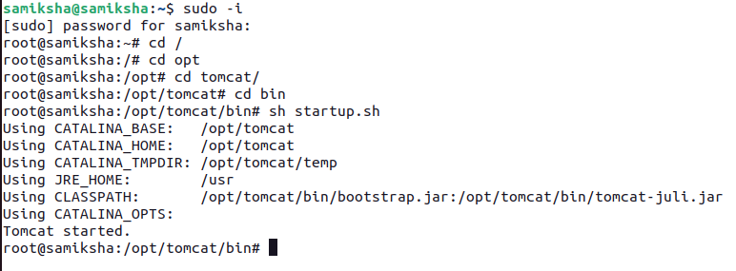
Step 8: Login to Manager app using the credentials given and select the path /MavenAnsibleWebApp1
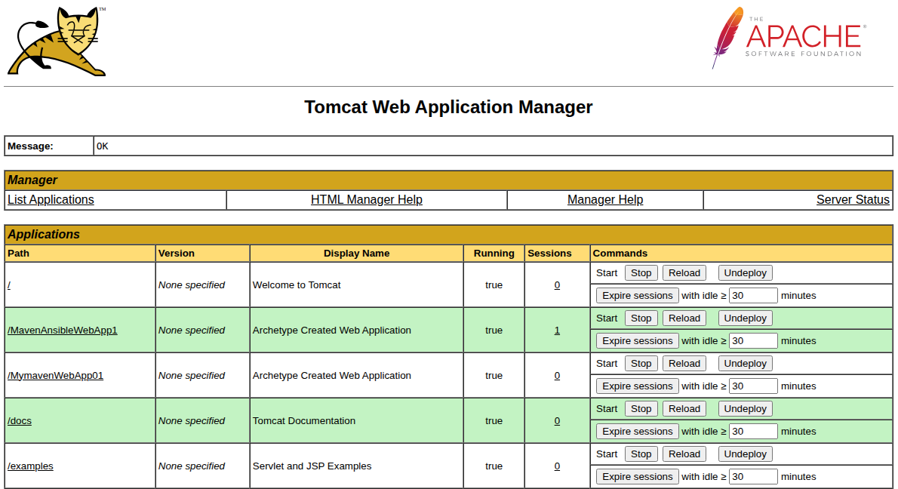
We will get hello world in the browser
